**DAY 1:**

**LAYING THE FOUNDATION FOR YOUR MARKETPLACE JOURNEY**

Before starting business, first of all we have to set some goals to grab Market. Here is Flowchart which shows details,

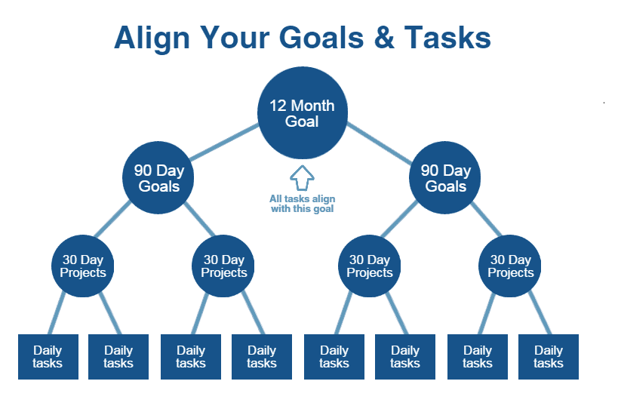

**20 Things to be Consider:**

* Need
* Uniqueness
* Identity
* Business Structure
* Market
* Specific Audience
* Startup Cost
* Funding
* Money Obligations
* Locations
* Employees
* Supplies and sourcing
* Regulation
* Accounts
* Brand
* Marketing
* Distribution
* Competitors
* Record Keeping
* Limits

1. **What is E-Commerce?**

An ecommerce business **sells products or services to customers over the internet**. Ecommerce businesses can range from small, home-based operations to large, ...

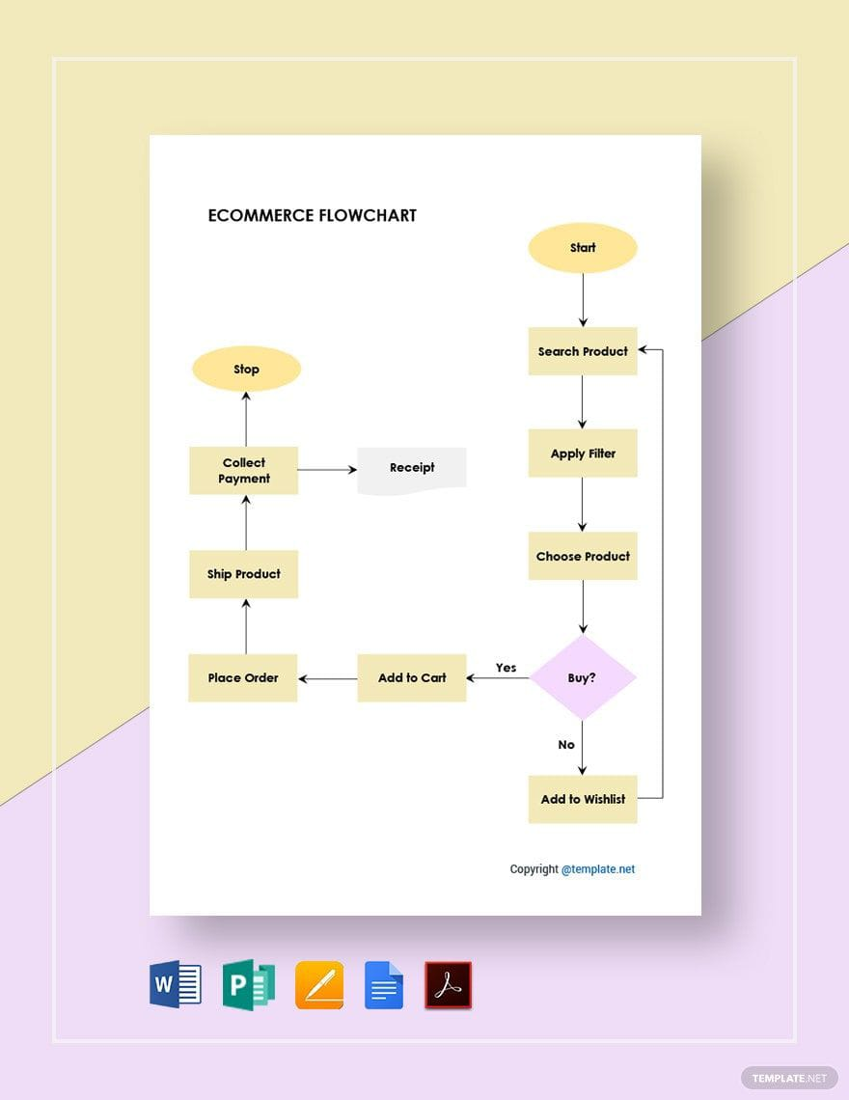

1. **What is Q-Commerce?**

A Q-commerce business is a business that sells products online and delivers them to customers within minutes or hours. Q-commerce is a type of e-commerce, but with a focus on speed and convenience.

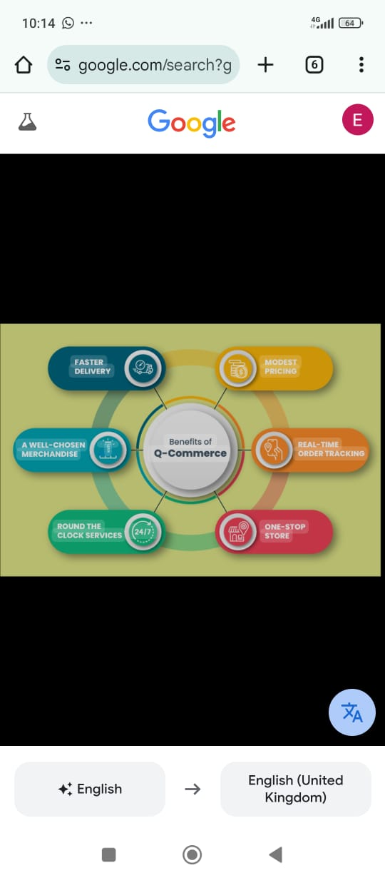

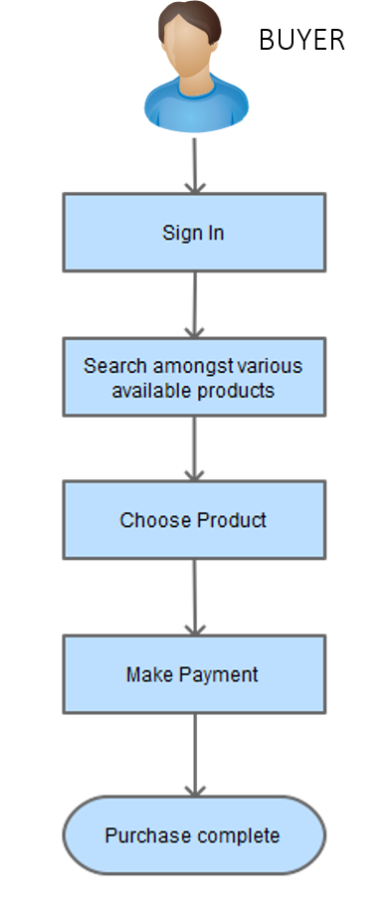

1. **What is Rental E-Commerce?**

A rental commerce business is a business that leases out assets, equipment, or property to customers for a fee. This model allows customers to use goods without purchasing them.

**Marketplace Type**

The platform acts as an intermediary, allowing sellers to list their products and buyers to browse and purchase.

**How it works**

* **Create the platform**: The marketplace owner builds the platform, either physically or digitally.
* **Invite sellers**: The owner invites sellers to register and sell their products on the platform.
* **Showcase products**: The owner showcases the products on the platform to attract buyers.
* **Facilitate transactions**: The owner facilitates transactions between the buyers and sellers.
* **Take a share of the revenue**: The owner takes a share of the revenue through commissions, subscriptions, or other means.

**Business Goals:**

* Customer satisfaction
* Employee business goals
* Market share
* Sustainability
* Growth goals
* Increase revenue
* Customer goals
* Employee development
* Employee engagement

**Data Schema:**

To create a data schema for a market, you can analyze the market's requirements, identify data entities, and define relationships between them. You can then design tables, implement relationships, and test and refine your schema.

[**Product]** - ID - Name - Price - Stock

**[Delivery Zone]**

Zone Name –

Coverage Area –

Assigned Driver

**[Shipment]** Shipment ID - Order ID –

Status -

[**Customer**]

Customer ID

Name

Contact Info

[**Order**]

Order ID - Customer ID - Product ID - Name - Quantity